# Data Engineering Assignment Documentation

#### By Shubhangi Sanjay

## Data Extraction and Loading

I have used Airbyte to extract data from Google Sheets and loaded it into Snowflake

Video Link to setup pipeline on AIrbyte:  
https://www.loom.com/share/f49526c4366e42d2b6eb8478ed141353?sid=3dd5bac5-d7b8-46ac-ace5-fe3fcafeb073

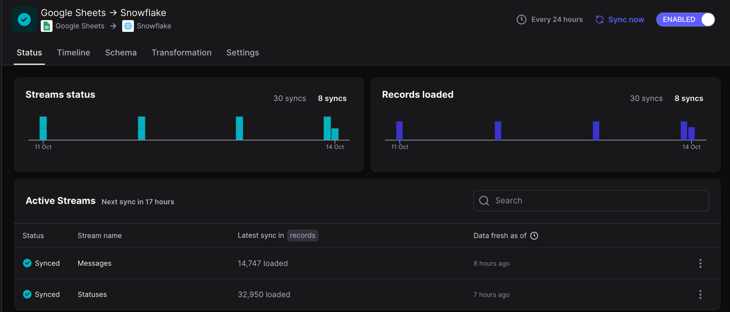

Data Transformation is done on Snowflake and all the queries are provided below in Data Transformation section.

## Data Transformation

### Row count validation to check ETL pipeline has successfully run.

Select id from messages

group by id

having count(id) > 1;

select id from statuses

group by id

having count(id) > 1;

*Verify the duplicate rows with the source data using Ctrl+F*

### Query to create table in Snowflake to store the result of merging tables – messages and statuses and store the data into the new table ‘combined_message_status’

CREATE OR REPLACE TABLE combined_message_status (

-- Message table columns

message_id STRING,

message_content STRING,

message_message_type STRING,

message_masked_addressee STRING,

message_masked_from_addr STRING,

message_direction STRING,

message_external_id STRING,

message_external_timestamp TIMESTAMP,

message_is_deleted BOOLEAN,

message_last_status STRING,

message_last_status_timestamp TIMESTAMP,

message_rendered_content STRING,

message_uuid STRING,

message_inserted_at TIMESTAMP,

message_updated_at TIMESTAMP,

-- Status table columns

status_id STRING,

status_status STRING,

status_timestamp TIMESTAMP,

status_uuid STRING,

status_message_uuid STRING,

status_number_id STRING,

status_inserted_at TIMESTAMP,

status_updated_at TIMESTAMP

);

*Here we have stored all columns from messages and statuses table with prefix message_ and status_ respectively. This is done keeping in mind future prospects.*

INSERT INTO combined_message_status (

message_id, message_content, message_message_type, message_masked_addressee,

message_masked_from_addr, message_direction, message_external_id,

message_external_timestamp, message_is_deleted, message_last_status,

message_last_status_timestamp, message_rendered_content, message_uuid,

message_inserted_at, message_updated_at,

status_id, status_status, status_timestamp, status_uuid, status_message_uuid,

status_number_id, status_inserted_at, status_updated_at

)

SELECT

-- Message table columns

distinct(m.id) AS message_id,

m.content AS message_content,

m.message_type AS message_message_type,

m.masked_addressees AS message_masked_addressee,

m.masked_from_addr AS message_masked_from_addr,

m.direction AS message_direction,

m.external_id AS message_external_id,

m.external_timestamp AS message_external_timestamp,

m.is_deleted AS message_is_deleted,

m.last_status AS message_last_status,

m.last_status_timestamp AS message_last_status_timestamp,

m.rendered_content AS message_rendered_content,

m.uuid AS message_uuid,

m.inserted_at AS message_inserted_at,

m.updated_at AS message_updated_at,

-- Status table columns

s.id AS status_id,

s.status AS status_status,

s.timestamp AS status_timestamp,

s.uuid AS status_uuid,

s.message_uuid AS status_message_uuid,

s.number_id AS status_number_id,

s.inserted_at AS status_inserted_at,

s.updated_at AS status_updated_at

FROM messages m

LEFT JOIN (

SELECT

s.*

,ROW_NUMBER() OVER (PARTITION BY s.message_uuid ORDER BY s.timestamp DESC) AS rn

FROM statuses s

) s

ON m.uuid = s.message_uuid

WHERE s.rn = 1;

Here we are selecting rows from status that are of status timestamp per message using message_uuid as it is uniquely identifying each message. We are doing this because we want one row per message in our new table.

### FLAGGING DUPLICATE VALUES

ALTER TABLE combined_message_status

ADD COLUMN record_status STRING;

*Adding an extra column record_status that will have value – Unique or Duplicate*

UPDATE combined_message_status

SET record_status = CASE

WHEN duplicate_check.rank > 1 THEN ‘Duplicate’

ELSE ‘Unique’

END

FROM (

SELECT

message_uuid,message_content,message_inserted_at,

DENSE_RANK() OVER (PARTITION BY message_content,

DATE_TRUNC(‘minute’, message_inserted_at)

ORDER BY message_inserted_at) AS rank

FROM combined_message_status

) AS duplicate_check

WHERE combined_message_status.message_uuid = duplicate_check.message_uuid;

*We are flagging values as duplicate when dense_rank function has rank more than 1 for a particular row, where content and inserted_at timestamp are the same.*

### VALIDATION CHECK

SELECT

COUNT(*) AS total_records,

SUM(CASE WHEN message_content IS NULL THEN 1 ELSE 0 END) AS null_content,

SUM(CASE WHEN message_message_type IS NULL THEN 1 ELSE 0 END) AS null_message_type,

SUM(CASE WHEN message_direction IS NULL THEN 1 ELSE 0 END) AS null_direction

FROM combined_message_status;

*Here we are checking for null values in content, null message type, direction.*

SELECT

COUNT(*) AS total_records,

SUM(CASE WHEN MESSAGE_UPDATED_AT < MESSAGE_INSERTED_AT THEN 1 ELSE 0 END) AS inconsistent_timestamps

FROM combined_message_status;

*Here we are checking for Consistency in Timestamps: Ensuring that the updated_at is always greater than or equal to inserted_at.*

### Data Integrity Check:

*Verifying that combined table has same records as source tables by checking count of tables from messages table, combined_message_status table. Here we are not checking statuses table because we have done a left join.*

Select count(*)

from messages;

--14,747

select count(*)

from combined_message_status;

--12848

select count(*) from

messages

where uuid not in

(select message_uuid from statuses);

--1899

*Here few records seem to be missing from messages table because their message_uuid were not found in statuses.*

## Data Visualisation

Data visualization is done on Google Collab. Here is the link with all necessary comments:

<https://colab.research.google.com/drive/1_kYA_wVPx88UqvjYY5sRTxOlQOYVeWyN?usp=sharing>